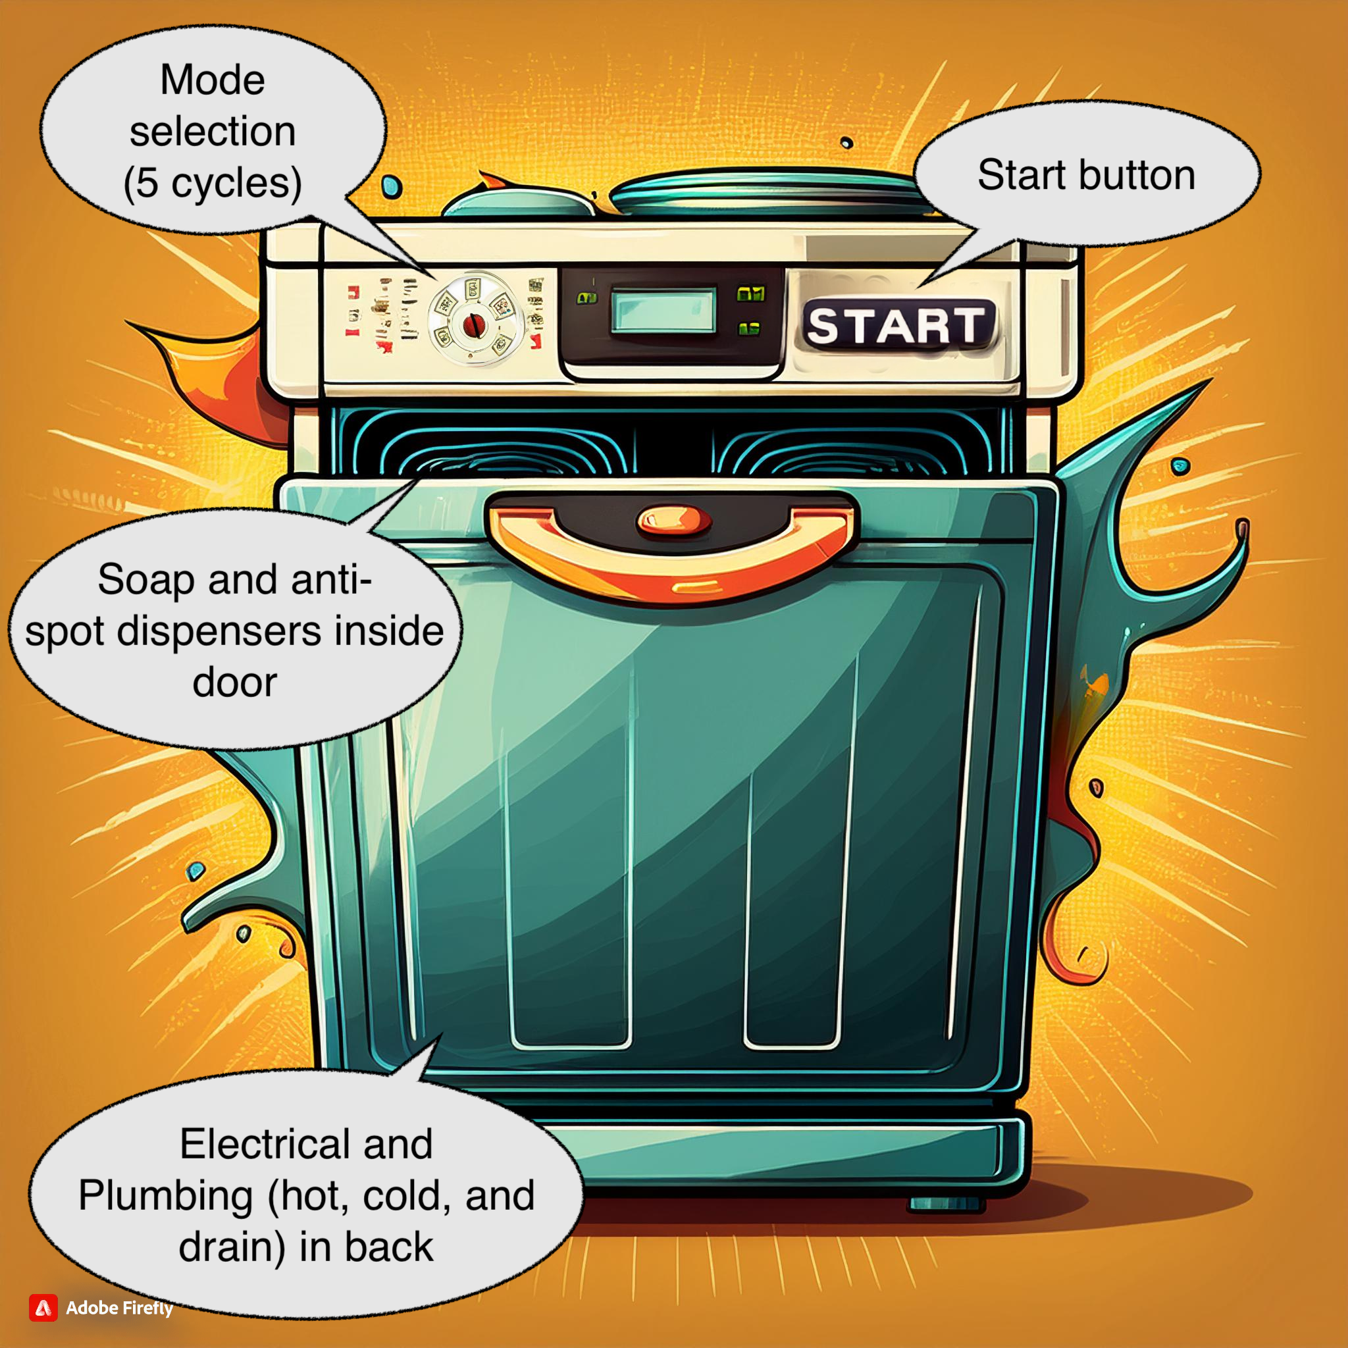
The Wonder (Budget) Washer: Overview
SF Enterprises had such success with their most recent product they were asked to create an economy version of their newest model with fewer features. Like most dishwashers, a user will put dishes in and start a wash cycle. SF has identified three different wash cycles they’d like to support based on extensive market research.
The new machine will be connected to hot and cold water. It will have a start button and a knob to select one of three different washing cycles. In addition, users will need to add soap and, optionally, may also add a liquid that ensures no water spots will be left on dishes.

Artists Rendition
An artists rendition of the final machine (generated by Adobe’s Firefly) is shown below:

User Story
A user would typically use the machine like:
- They’d put dirty dishes in the machine.
- They’d select the type of wash cycle they’d like to run:
  - Power Wash & Sanitize,
  - Power Wash Warm & Sanitize, or
  - Fast Wash & Anti Spot
- They’d add soap to the soap dispenser. They may also add anti-spotting liquid to the anti-spotting dispenser if they are using the “Fast Wash & Anti Spot” wash cycle.
- They’d hit the start button.
- Depending on the wash cycle they chose, they’ll wait about 30-40 minutes for the dishwasher to move through the different phases needed to do that wash cycle.

Outputs
The mechanical engineers have installed a variety of electrical and electromechanical devices that can be used for all the needed functionality. Here is a list of the various connections (output pins) and how they work:
- Soap: When a 1 the machine releases the contents of the soap dispenser
- Hot: When a 1 the machine opens the hot water valve to be used in washing/rinsing
- Cold: When a 1 the machine opens the cold water valve to be used in washing/rinsing
- HighPressure: When a 1 the hot and/or cold water pressures are significantly increased, which is good for cleaning food that’s really stuck to dishes. This is used in the two “Power Wash” cycles.
- UVSanitize: When a 1 the ultraviolet lights are on and dishes will be sanitized
- AntiSpot: When a 1 the machine releases the contents of the anti-spotting dispenser

Inputs
There are three inputs (a total of 5 bits):
- Start: When the machine is idle and Start is a 1, the user would like the machine to start a wash cycle. The machine will start washing at the next clock cycle. Start should be ignored while the machine is busy washing dishes.
- Mode: Mode is a knob that provides a 2-bit value. The value helps identify the cycle:
Mode Value | Mode Name
01 | Power Wash & Sanitize
10 | Power Wash Warm & Sanitize
11 | Fast Wash & Anti Spot
SF’s mechanical engineering team indicates that other values of Mode will never occur, so you can ignore them.
- Clock: The clock. An actual machine will adjust it to be ~10 minutes for each phase of a wash cycle.

Wash Cycles
Below the phases of each wash cycle are described.
All the wash cycles start with a phase that releases soap and hot water. Next they all go through a phase that rinses the soap off the dishes, but the details of how they rinse differ based on the specific wash cycle chosen.

Power Wash & Sanitize
- Soap is released and hot water is used to wash the dishes
- High pressure cold water is used to rinse the dishes
- UV Sanitizer is used to sanitize the dishes

Power Wash Warm & Sanitize
- Soap is released and hot water is used to wash the dishes
- High pressure warm water (a mix of both hot and cold) is used to rinse the dishes
- UV Sanitizer is used to sanitize the dishes

Fast Wash & Anti Spot
- Soap is released and hot water is used to wash the dishes
- Cold water is used to rinse the dishes AND the anti-spotting agent is dispensed

Requirements / Review
- The CEOs of SF Enterprises for some reason think “Moore is More” and are demanding that a Moore machine be used. (They may not know much about engineering, but they are funding the project so you should follow their request).
- The machine should start in an idle state, where it is waiting for Start.
- The machine should return to the idle state when done.

Suggested workflow

